Foreigner Job Market Trend Analysis in USA

|  |  |  |
| --- | --- | --- |
| Data : | 2022/08/13 |  |
| Writer : | DaeHan Kim |  |
| Edit : | JaeHee Song |  |

1. **Abstract**

The purpose of this report is to analyze and grasp the employment trends in the current American society targeting Koreans currently preparing to get a job in the United States and deliver useful information. The data set used is Performance Date provided by U.S. DEPARTMENT OF LABOR (DOL) was used, and the data showed that the current American society has seen rapid development in the IT field since the Fourth Industrial Revolution, and more than half of the incoming workers' majors and jobs focused on the computer field. The main inflow areas were California, where Silicon Valley is located, and Texas, where Silicon Hills is located. Koreans tend to be similar to the U.S. employment trend, but the average wage was about 26% lower and was very focused on California. Texas, which ranks second in inflow, was found to be relatively less interested. In the case of Texas, the average wage is somewhat cheaper than that of California, but it is forming an industrial complex that is drawing keen attention from start-up companies due to low prices and regulations. Through this, it is proposed to pay attention to Texas as a target for regional consideration for employment in the United States.

1. **Introduction**

In order to understand the current trend of the US foreign employment market, a comprehensive analysis was conducted based on LCA, PW, and PERM, which are datasets provided by DOL. The description of each dataset is as follows

* LCA stands for ‘*Labor Condition Application*’ and refers to the application of a U.S. business operator on behalf of a foreign national when a specific type of non-immigrant applies for a work visa. Employers generally have to submit an LCA before hiring an employee with H-1B, E-3, etc.
* PW stands for *‘Prevailing Wages’* and is to set the minimum wage by region and occupation to protect the labor force of Americans in their own country and to protect the unemployment rate. The reason for the existence of PW is of great significance to preventing the adverse impact on the U.S. workforce market by guaranteeing the same level of salary that U.S. employers pay to U.S. workers when hiring foreigners
* PERM stands for *‘Program Electronic Review Management’*, which refers to a system in which the U.S. Labor Office computerizes Labor Certification management and manages and supervises it online.

EDA was conducted through each dataset, and significant data were extracted based on this. Basically, in the case of PW, it was analyzed based on annual salary, and it was not included in the case of Expired data on the document. In the case of VISA, all types of visas were included for the overall analysis, most of which were dominated by H-1B.

1. **Overall Job Market Trend in USA**
2. **Employee**

Identify the characteristics and trends of employees flowing into the U.S.

* **Foreigner Employee Country Pie Chart**

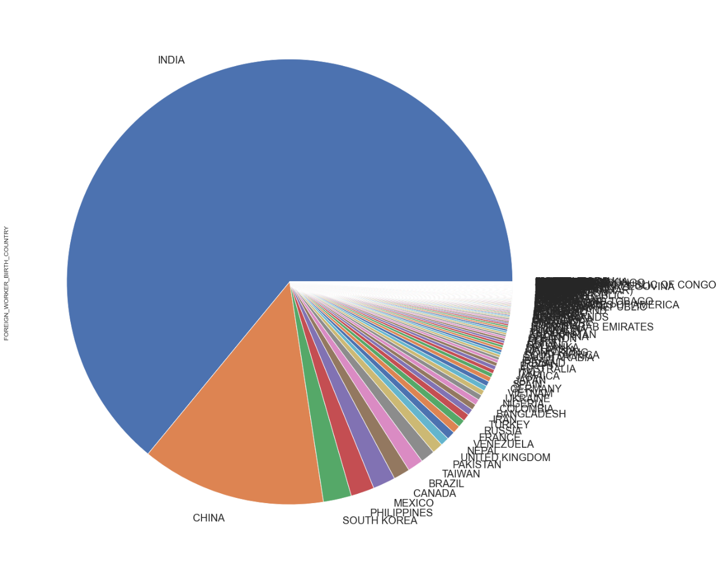

Out of 164 countries, 64% of foreign employees in the United States were Indians, followed by China with 13% and Korea with 2%. Since then, Philippines, Mexico, and Canada have followed in a similar ratio to Korea.

* **Worksite Distribution of Foreigner Worker in USA**

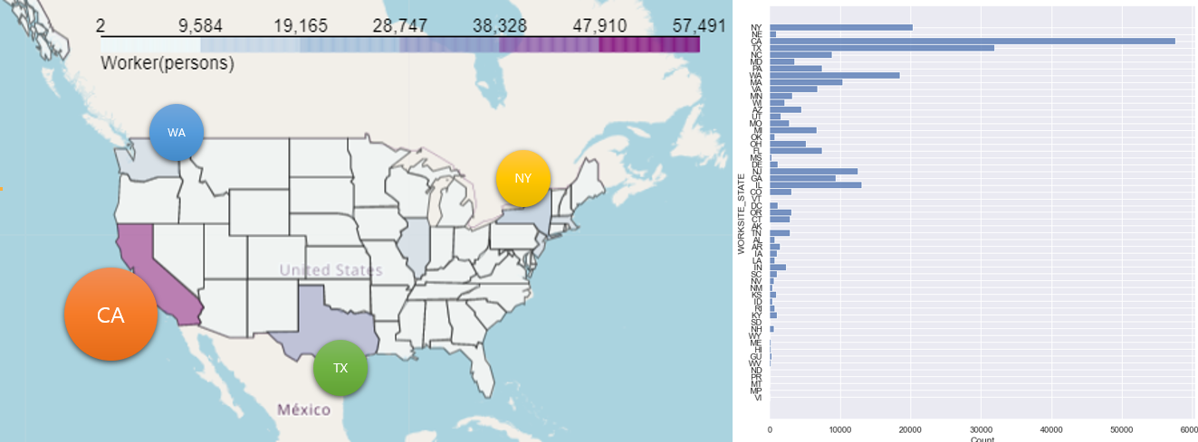

According to the data, California had the highest number of foreign workers at 21% of the total 57491 samples, followed by Texas at about 12%. It was followed by New York and Washington.

* **Top 20 SOC Title of of Foreigner Worker in USA Tree Map**

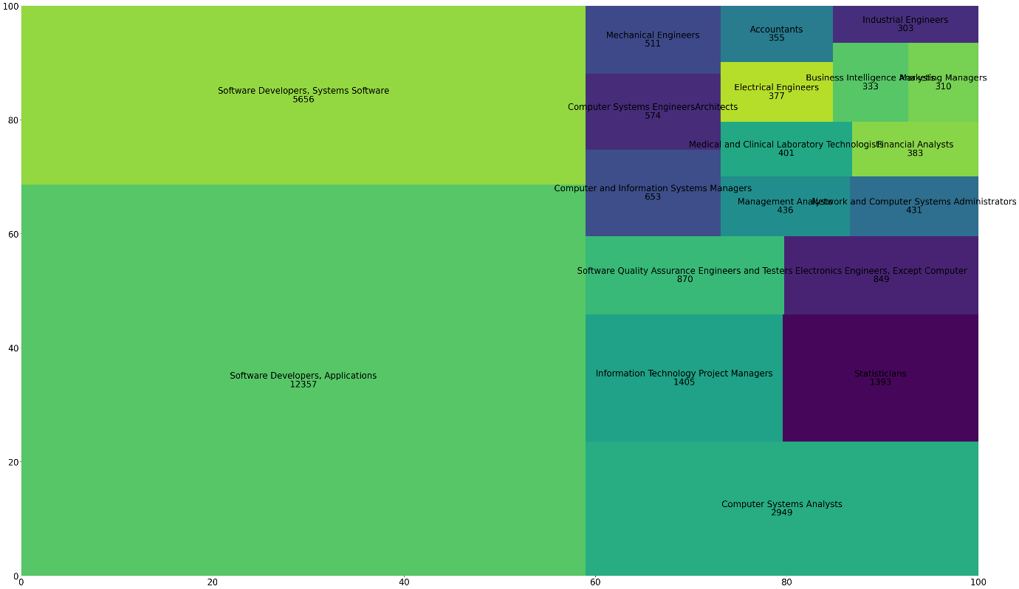

Looking at the top 20 SOC of foreign workers, most of the jobs were related to CS, and through the above results, experts in computer jobs around the world intuitively flow into California and Texas the U.S., and India accounts for the largest influx. Based on the above data, it can be inferred that the source of the influx of IT personnel is ‘**Silicon Valley’** in California and ‘**Silicon Hills’** in Texas. Silicon Valley is a representative high-tech industrial complex in the United States, with research institutes and companies dealing with various IT and high-tech technologies. In the case of Silicon Hills, Tesla founder Elon Musk announced that Tesla's headquarters will be relocated to Austin, Texas by 2021, and Samsung Electronics has also selected the second foundry factory site in the U.S. to Texas.

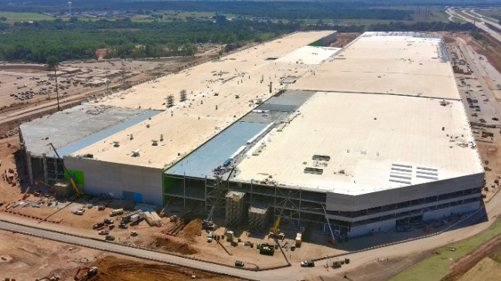 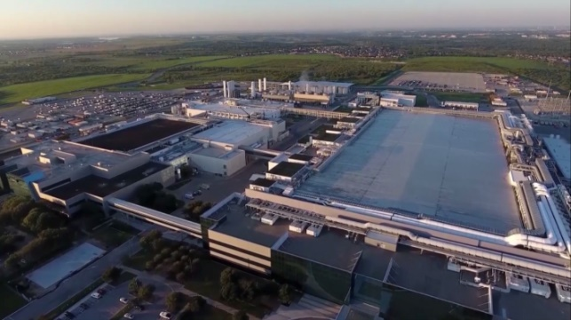

Tesla, electric vehicle manufacturer, "Giga Factory"(left) and Samsung Electronics Austin plant(right) in Texas.

1. **California VS Texas**

A schematic data analysis confirmed that 33% of foreign workers flowing into the United States were California and Texas. In addition, CS-related jobs and Silicon Valley and Silicon Hills are located in each state suggest that most of the workers entering the U.S. are computer workers and are employed in Silicon Valley and Silicon Hills, where it and advanced industries are developed. Based on this, we checked the difference between California and Texas.

* **Prevailing Wage Distribution histogram in CA & TX**

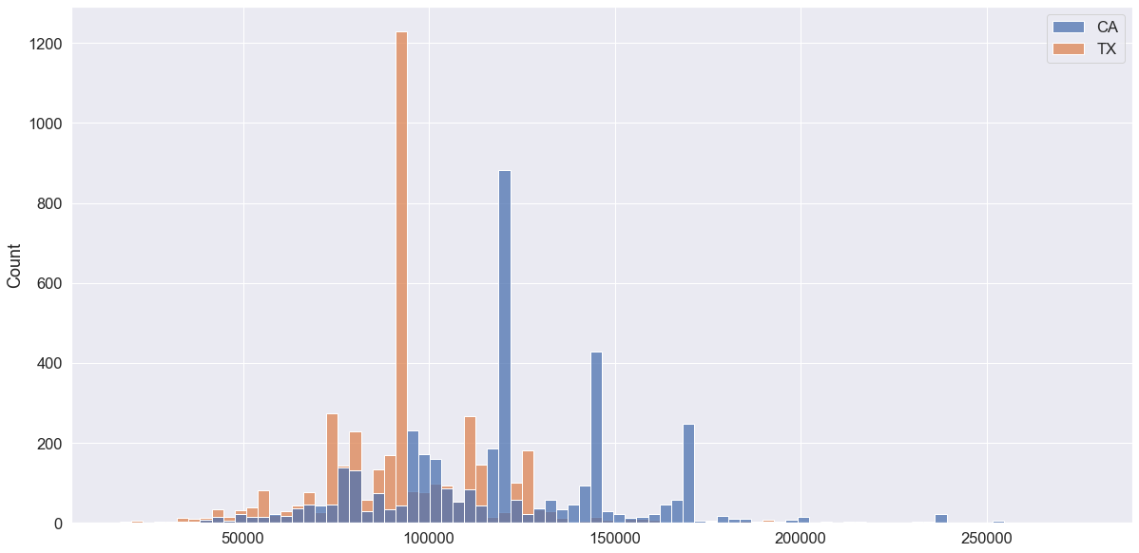

Overall, it can be seen that there is a PW gap of about $20,000 between California and Texas. There may be many reasons for policy differences or educational background differences between states, but the main reason will be California's murderous prices.

* **Distribution Prevailing Wage in USA**

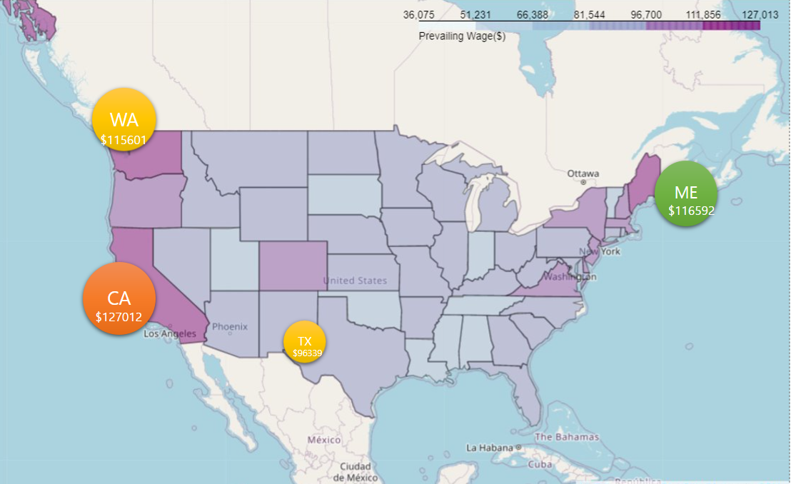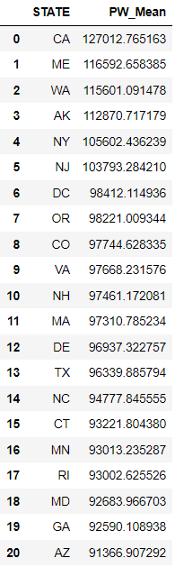

Also, compared to other states, Texas' PW was not very high. On the basis of LCA dataset, the PW average was an overwhelmingly high approximately $127,000, and for Texas it ranked 13th out of approximately $96,000 50 states.

* **Minimum Education Pie Chart in CA & TX**

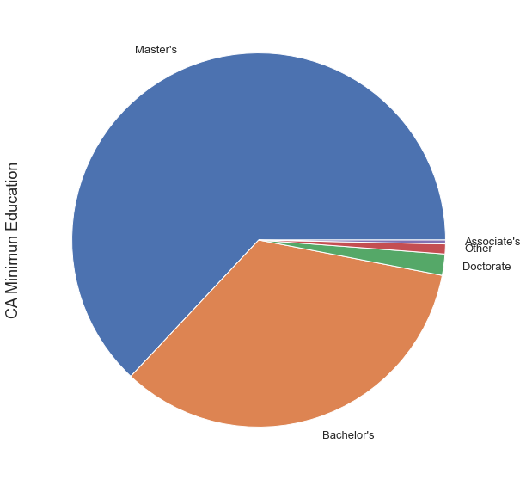 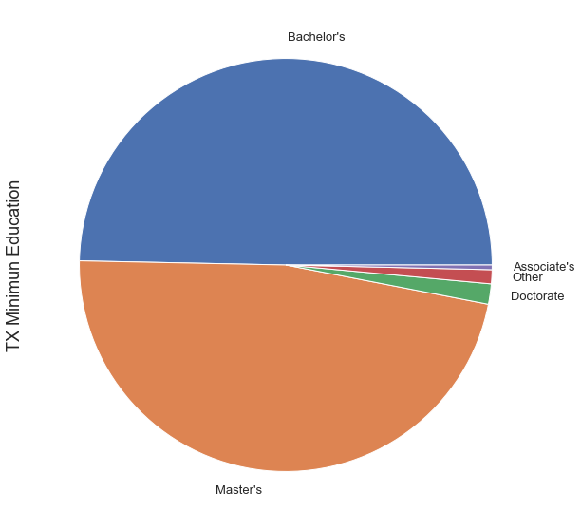

Compared to California and Texas, California had a relatively higher percentage of masters than Texas, and Texas had a relatively higher percentage of bachelor's degrees. It can be confirmed that the difference in PW confirmed above also exists due to the difference in educational background.

* **Top 10 Market Cap in USA**

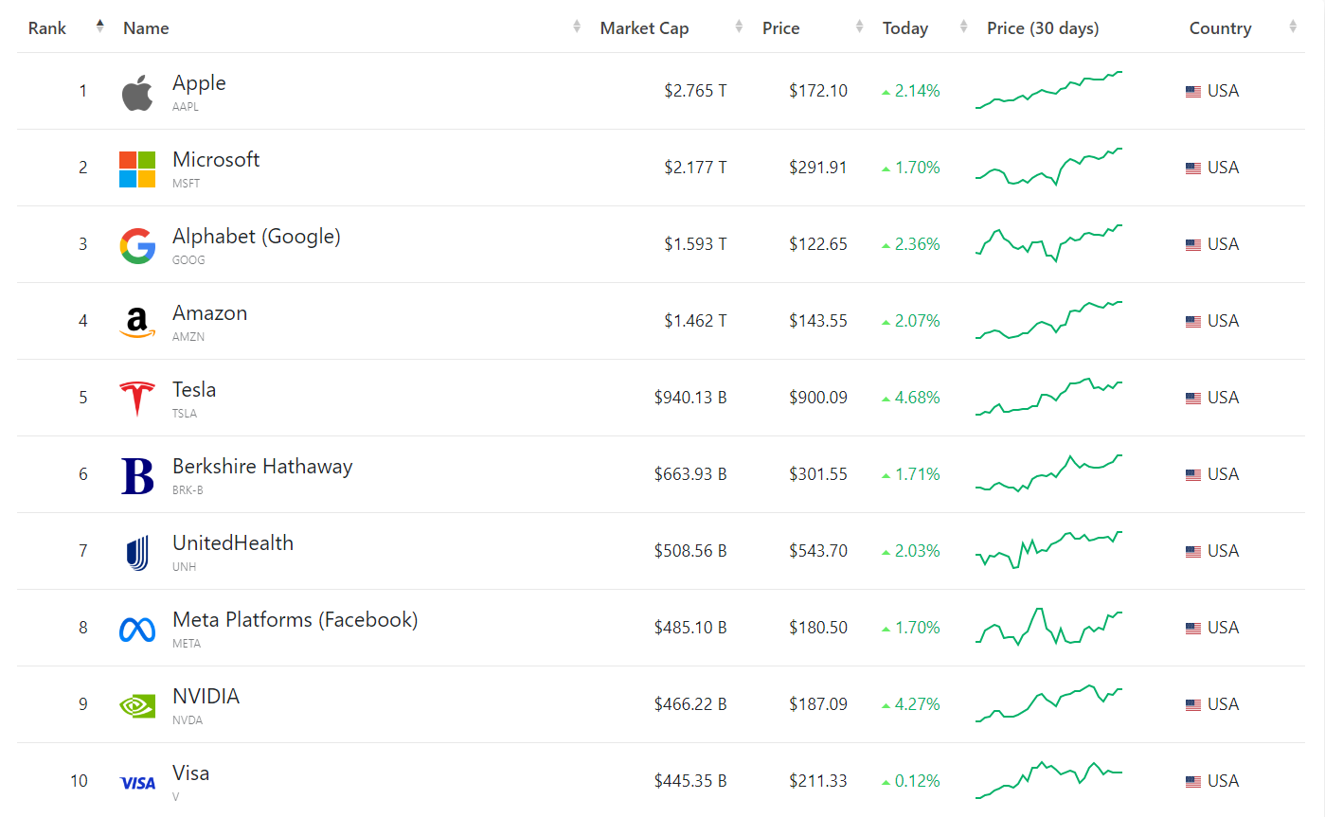

* **Employer Company in CA & TX**

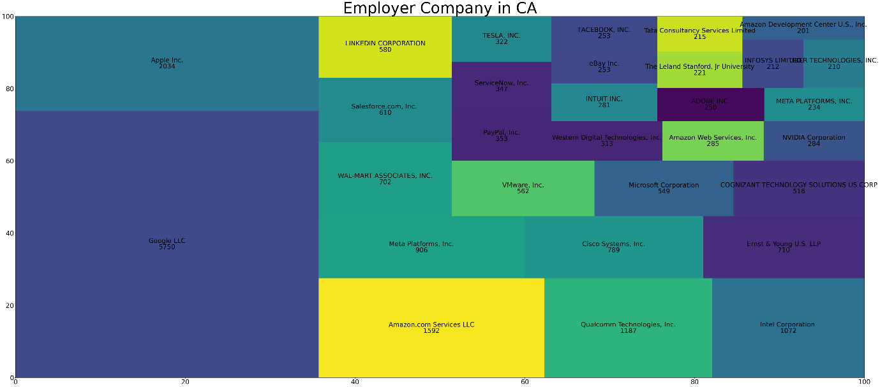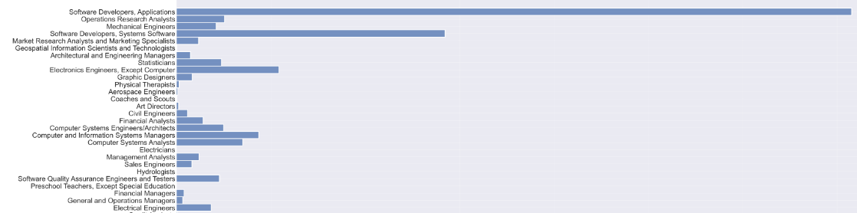

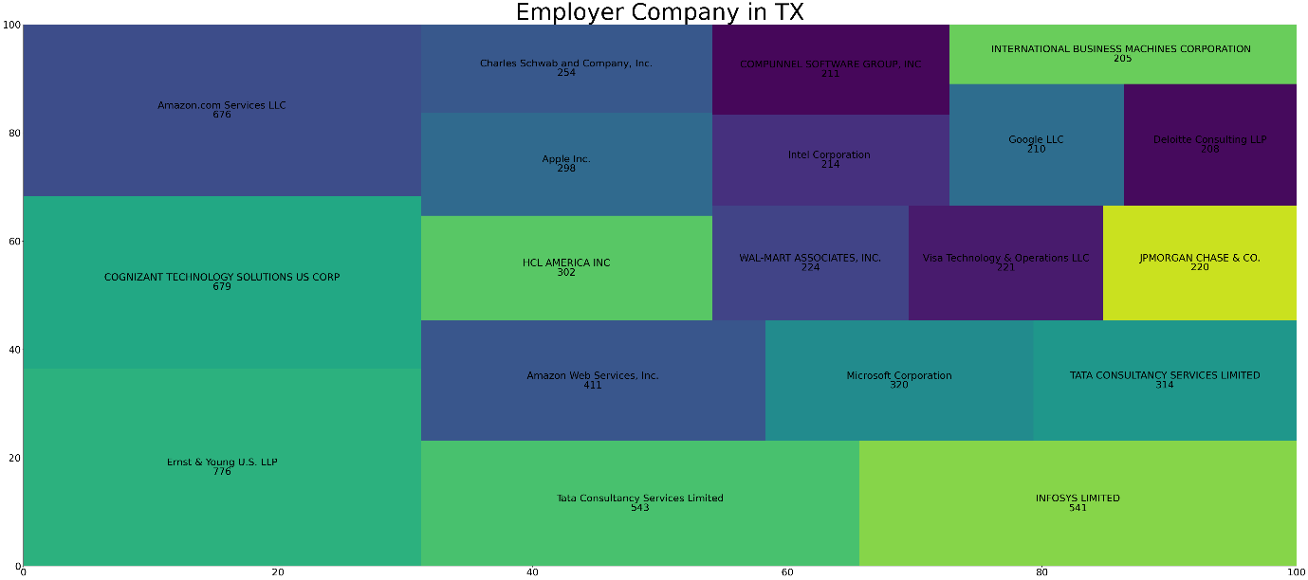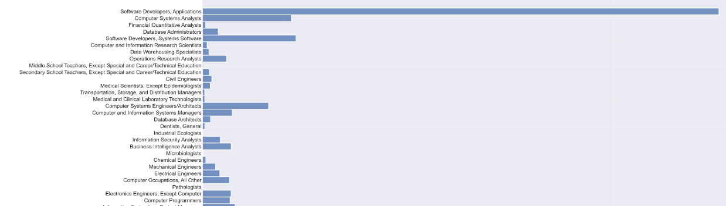

In general, computer jobs were dominant in California and Texas, and all but a few were IT companies. Most of the top market cap companies in the U.S. were also found to overlap a lot of major companies in California and Texas (Google, Apple, Amazon, Intel, etc. Through this, it was confirmed that the two regions were inevitably technically and economically important.

1. **Korean Job Market Trend in USA**

Through the previous analysis, we briefly analyzed the current employment trends and characteristics of the United States. This time, we will analyze the data of Koreans entering American society to understand the fields and characteristics of Koreans entering American society.

1. **Worksite**

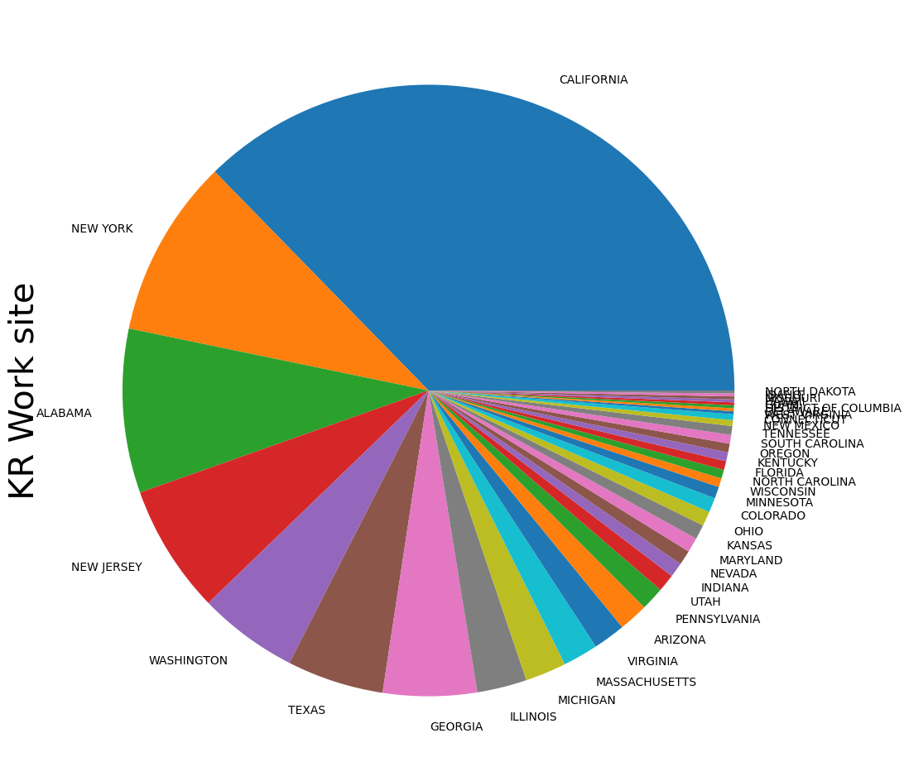

Similar to the overall statistics, California topped the list with an overwhelming 37%. It was followed by New York and Alabama. In the case of Alabama, LG Electronics is operating a factory in Huntsville and Hyundai Motor is operating a local factory in Montgomery, so it is estimated that it will be ranked high because the southern states have the second largest number of Koreans after Georgia. Uniquely, it can be seen that Texas is less popular because it is limited to Koreans. Like Silicon Hills, Texas has enough IT industries and infrastructure, but it can be confirmed that Koreans are not yet highly aware of Texas. This may be the influence of Texas' conservative political orientation and the image of Redneck, which often appears in the media.

1. **Prevailing Wage**

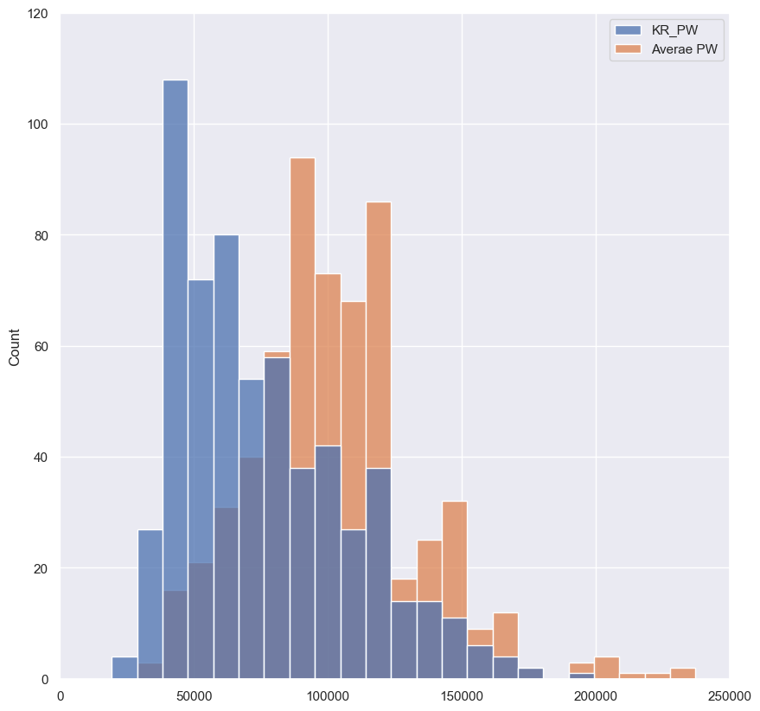 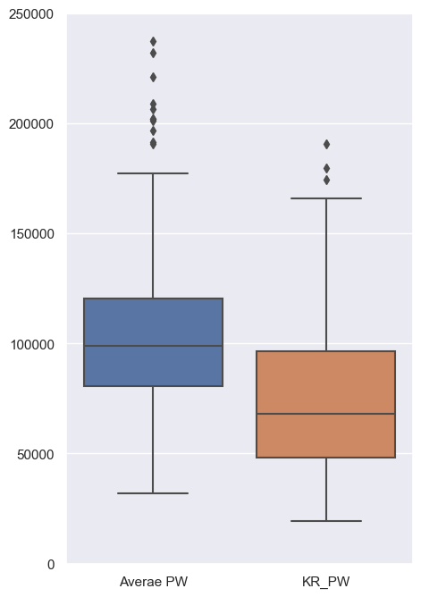

The analysis randomly extracted and compared the number of samples of the data to 600, and the average of the average PW of the extracted dataset was $102,439, and the average of KR-PW was $75,770. Unfortunately, it has been confirmed that the PW of Koreans is 26% less than the overall PW of American society. Overall, it can be seen that all sections were lower than the average PW, and the distribution was more skewed downward.

1. **SOC Title**

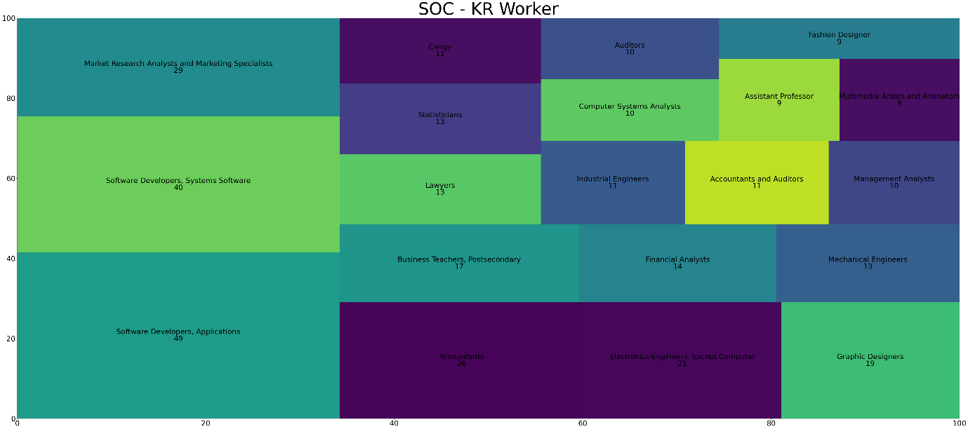

Although application and system software, which are still in the CS field, account for the main SOC, it can be seen that Koreans are employed in relatively various fields.

1. **Employer Company**

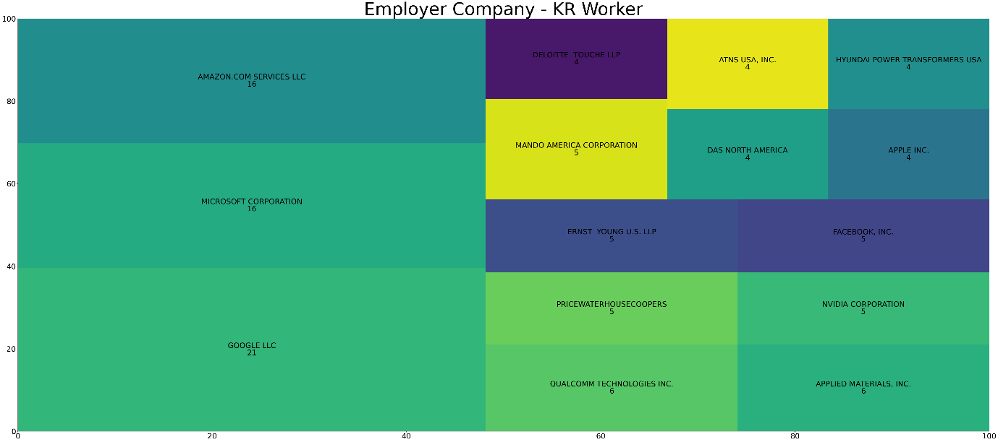

Representative IT companies such as Google, Microsoft, and Amazon ranked, all of which are presumed to be located in Silicon Valley.

1. **Education**

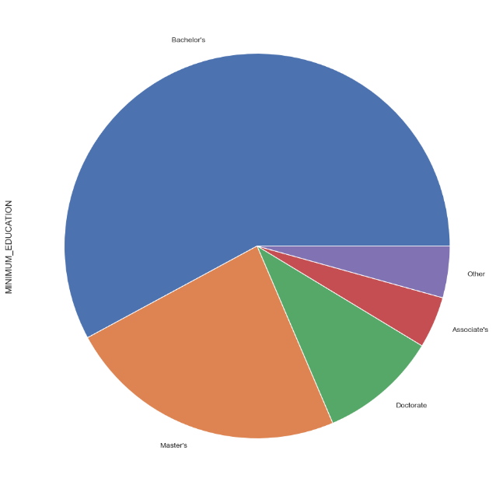

More than the above-mentioned bachelor's degree proportion in California and Texa, Korean have a 55% bachelor's degree, and about 24% have a master's degree. In the unique part, it can be seen that the ratio of doctors increased slightly compared to the low ratio of masters. This is considered to be closely related to Korean sentiment, which is considered a common route to enter the U.S. by going to the U.S. with a Doctor's degree at a domestic graduate school.

1. **Conclusion**

In conclusion, it was confirmed that the trend of the US foreign worker market was generally very focused on the CS field in time for the 4th industrial period. Through this, many workers are flowing into California and Texas, which are building high-tech IT industrial complexes. Korean also showed a similar pattern overall according to this trend, but it was confirmed that the PW was relatively 26% lower than other foreign workers on a PERM dataset basis. In addition, it can be seen that the proportion of Koreans entering Texas is relatively small, which is likely to be somewhat negative for Koreans to recognize Texas. However, Texas is cheaper than California in terms of prices and taxes, and a number of star companies are currently located in Silicon Hills, and large companies are also building a number of factories on the Texas site. In order for Koreans to enter the U.S. stably and strategically, it is important to grasp the possibility of Texas, not California, such as the Red Ocean.

[1]**Reference**

1. Employment and Training Administration. (2022). [*PERM_Disclosure_Data_FY2022Q2.xlsx*](https://www.dol.gov/sites/dolgov/files/ETA/oflc/pdfs/PERM_Disclosure_Data_FY2022_Q2.xlsx)*.*

   <https://www.dol.gov/sites/dolgov/files/ETA/oflc/pdfs/PERM_Disclosure_Data_FY2022_Q2.xlsx>

   Employment and Training Administration. (2022). [*LCA_Disclosure_Data_FY2022_Q2.xlsx*](https://www.dol.gov/sites/dolgov/files/ETA/oflc/pdfs/LCA_Disclosure_Data_FY2022_Q2.xlsx)*.* <https://www.dol.gov/sites/dolgov/files/ETA/oflc/pdfs/PW_Disclosure_Data_FY2022_Q2_old_form.xlsx>

   Employment and Training Administration. (2022). [*PW_Disclosure_Data_FY2022_Q2_old_form.xlsx*](https://www.dol.gov/sites/dolgov/files/ETA/oflc/pdfs/PW_Disclosure_Data_FY2022_Q2_old_form.xlsx)*.* <https://www.dol.gov/sites/dolgov/files/ETA/oflc/pdfs/LCA_Disclosure_Data_FY2022_Q2.xlsx>